Continental Drift and Plate Tectonics Webquest:
Name ____________________________________ Date __________ Period ___
Part A: Continental Drift
Type this web address in the address window of Internet Explorer:
http://www.enchantedlearning.com/subjects/dinosaurs/glossary/Contdrift.shtml
a. What does the Theory of Continental Drift state?

b. What is the name of the scientist that proposed the Theory of Continental Drift?

c. What was Pangaea?

d. What are the names of the two continents that Pangaea separated into?

- Type the following website into the address window of Internet Explorer.
http://www.openschool.bc.ca/features/samples/sc10_sample.pdf

a. How do the continental coastlines support the Theory of Continental Drift (Pangaea Theory)?

b. Explain how fossil distribution supports the Theory of Continental drift.

c. How do distinctive rock strata support the Theory of Continental Drift?

d. How does coal distribution support the Theory of Continental Drift?

Part B: Plate Tectonics
Type this website into the address window of Internet Explorer:
http://pubs.usgs.gov/gip/dynamic/dynamic.html
Click on the “Historical Perspective” icon on this website.
1. What is a “plate” in geological terms?

2. What does the Theory of Plate Tectonics state?

3. What is the name of the theory that led to the development of the Theory of Plate Tectonics?

4. Click the back arrow of Internet Explorer to return to the homepage of http://pubs.usgs.gov/gip/dynamic/dynamic.html : Click on the “Understanding Plate Motions” icon on this website.

5. What are the four types of plate boundaries?
a. __________________________________________________________

b. __________________________________________________________

c. __________________________________________________________

d. .__________________________________________________________

Click on Illustration of the Main Types of Plate Boundaries [55 k]
Label the diagram below
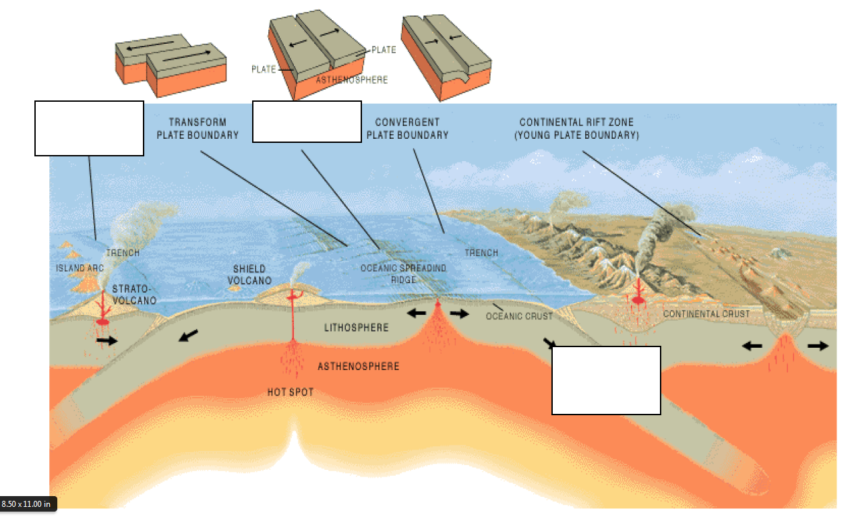

Part C: Plate Tectonics: Types of Boundaries: Divergent boundaries
Click the back arrow once on the Internet Explorer screen to move back one page. Scroll down to: Divergent Boundaries.
Finish the following sentence.
Divergent boundaries occur along spreading centers where
___________________ are moving __________________ and new crust is
created by _________________ pushing up from the _________________.

Click on the link: Mid-Atlantic Ridge [26 k]
- What is shown in this picture? What type of plate boundary is it? Where is it located?

Part D: Plate Tectonics: Types of Boundaries: Convergent Boundaries
Scroll down to: Convergent Boundaries.
- What is the location where sinking of a plate occurs is called? _______________________ _____________________.

- The type of convergence -- called by some a very slow "collision" -- that takes place between plates depends on the kind of lithosphere involved. Convergence can occur between what types of plates?

- __________________________________________________________

- __________________________________________________________

- __________________________________________________________

Scroll down to: Oceanic-continental convergence
- Off the coast of South America along the Peru-Chile trench, the oceanic Nazca Plate is pushing into and being subducted under the continental part of the South American Plate creating what?

- Look at the diagram under the Oceanic-continental convergence information: Label diagram.
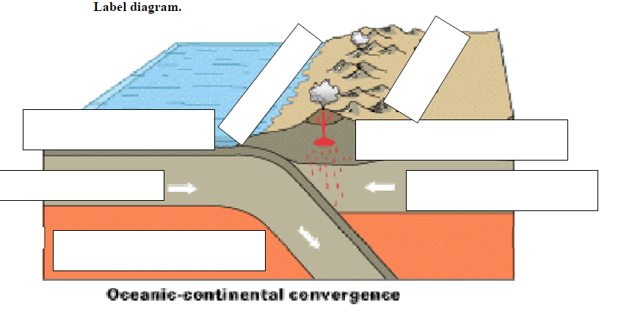
Click on the Ring of Fire [76 k]
- What is the ring of fire?

- The Ring of fire results in frequent what?

- The West coast of the United States has frequent volcanoes, use the ring of fire to explain why.

Part E: Plate Tectonics: Types of Boundaries: Convergent Boundaries continued
Scroll down to: Oceanic-Oceanic convergence
- When two oceanic plates converge, one is usually subducted under the other what is formed?

Scroll down to: Continental-continental convergence
- What mountain range demonstrates one of the most visible and spectacular consequences of plate tectonics?

- What happens when two continents meet head-on, meet head-on and neither is subducted?

Look at the diagram under the Continental-continental information: Label diagram.
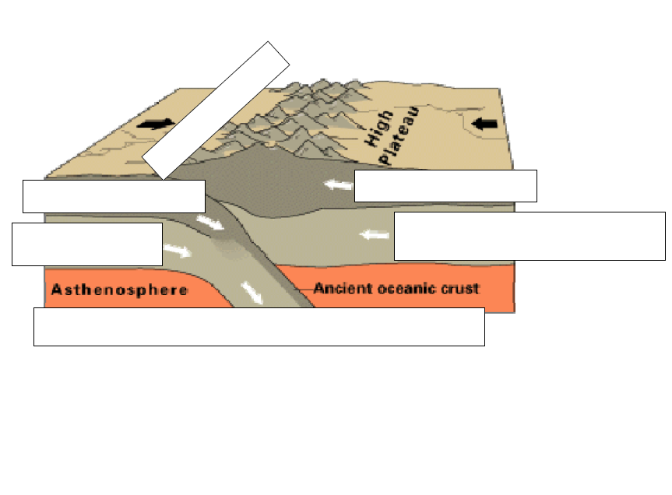
Part F: Plate Tectonics: Types of Boundaries: Transform Boundaries
Scroll down to: Transform Boundararies:
The zone between two plates sliding horizontally past one another is called a transform-fault boundary, or simply a ____________________________ _____________________________.

Click on the diagram San Andreas fault [52 k]
a. The picture is an aerial view of what?

b. Make three observations about the picture

c. What type of boundary does it results from?

